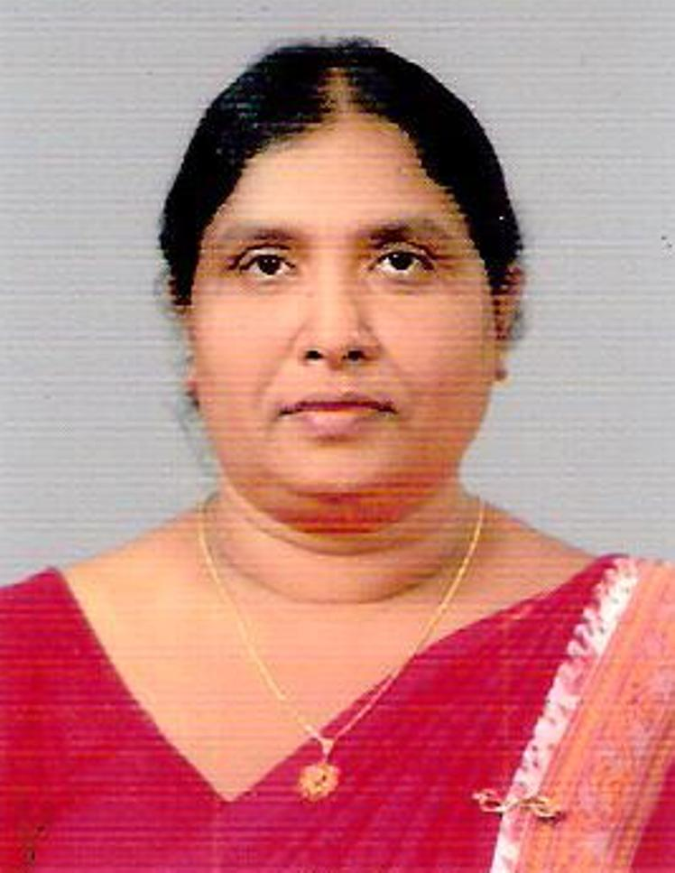
G.A.D.Wimala Ranatunga
No.54, Rawathawatte Road, Moratuwa
Contact No: +94 - 77- 7800105 / 714420772
E-mail: wimalasarvodaya@gmail.com

Personal Details:

- Name in Full : G.A.D.Wimala Ranatunga

- Date of Birth : 27-10-1956 Age : 54 years

- Gender : Female

- Marital Status : Married

- Nationality : Sri Lankan

- Religion : Buddhist

- Residence Address : No.54, Rawathawatte Road, Moratuwa

- Contact No : +94 - 77- 7800105 / 714420772

Present Employment:

- Executive Assistant of Sarvodaya Shramadana Movement

Responsibilities:

- Coordination of Health Project and programmes
- Development of Health related project proposals
- Planning , Organizing, Monitoring and Evaluating the projects of the unit with the project team
- Preparation of training curricular and the implementation of training of trainers on gender based violence and reproductive health at field level
- Progress reports on projects implemented
- Administrative support the head of the unit

- Programme Officer on Prevention of HIV/AIDS for Sex Workers under the Global Fund (GFATM)

- Official Address:
Sarvodaya Community Health Unit, 155/A, Nagarodaya Centre, Dr. Danister de Silva Mawatha, Borella, Colombo – 08

- Telephone No: +94-11-2667360/ 2667365 Fax No: +94-11-2667359

Extra Work Experience:

- Vice President at Sarvodaya Women’s Movement from year 2009 up to now
- Executive Member of Sarvodaya Suwasetha Sewa Society from year 200 up to now
- Member of Executive Council at Sarvodaya Shramadana Movement from year 2000 up to now

Educational Qualifications:

- General Certificate Examination – Advance Level in Science Stream

Academic Qualifications:

- Foundation Course in Social Studies in year 1992/1993 at Open University, Nawala, Nugegoda in Sri Lanka
- Management Diploma in year 1994/1995 at Open University, Nawala, Nugegoda in Sri Lanka

Special Award Received:

“Excellent Service Award for year 2006 received from Sri Lanka – United Nations Friendship Organization-SUNFO”

Professional Qualifications:

- Diploma in Family Life Education and Counseling in year 1986/87 at Family Studies and Services, Malwatte Road, Colombo -11, Sri Lanka
- Following the Diploma Course in Women & Political Empowerment for Women’s Leaders conducted by the Ministry of Child Development and Women’s Empowerment in Sri Lanka ( 01st year / March, 2011- April, 2012)

Professional Experience:

- Senior Trainer
- Training and Experience in Counseling
- Strong ability in Project management
- Excellent interpersonal skill
- Professional teaching skill

Course Followed:

- Child Development and Women’s Empowerment at Ministry of Child Development and Women’s Empowerment in year 2006
- Training of Trainers for the Management of Women’s Centers for Women affected by Tsunami at National Committee on Women, Colombo – 06, Sri Lanka in year 2006
- Training Programme on Prevention of GBV & Women’s Development at Women’s development Centre, Madras in year 2003
- Course in Breastfeeding Counseling and Logical Framework Approach Training, New Delhi, India in year 2002
- Reproductive Health and Counseling at Chulalancon University, Bangkok in year 2001
- Prevention of HIV/AIDS and Community Participation , Thailand in year 1997
- Health care Management at IRRR Institute, Philippines in year 1994
- International Course on Adult Education , Malaysia in year 1998
- Women and Leadership at Women’s Education Centre, University of Colombo in year 1987
- International workshop on Community Health and Basic Health Care, Japan in year 1983

Referees:

Dr.Vinya Ariyaratne
M.D., MPH., Msc. (Comm.Med)., M.D. Comm.Med.) Dr.Neela Gunasekara
General Secretary Chairperson – National Committee on
Sarvodaya Shramadana Movement Women, Ministry of Child Development
No.98, Rawathawatte Road and women’s Affairs, Nawala Road
Moratuwa Nugegoda
011-2647159/2655255 011-2827002/2827003
vinya@sarvodaya.org neelagunasekara@gmail.com

I further wish to state that I had followed a number of programme on health and nutrition, maternal and child care, breast feeding in emergencies, reproductive health, Gender Based Violence and many other programmes.

I do herby certify that the above mentioned are true and correct to my knowledge.
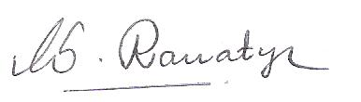

Date: 03-05-2011 Signature of the Applicant:

